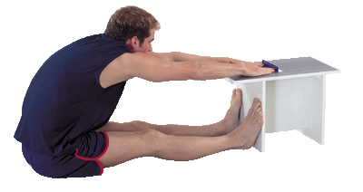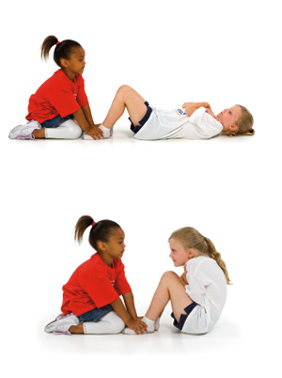

**6th GradeTrimester 2 Study Text**

## **Training Terms**

## Repetition—the number of times you repeat and exercise

## Sets—A number of repetitions

## Resistance—Amount of weight working against your muscle

**Stretching**

**Should be done towards the end of an activity**

**Helps prevent injury**

**Improves athletic performance**

**Reduces muscle soreness**

**Should be held for 20-30 seconds**

**Should be done is a slow,**

**steady manner**

**Phy Ed Beliefs**

**Improving personal muscular strength and muscular endurance are important for a healthy life style along with flexibility and cardiovascular fitness**

**It is important to follow proper form while strength training not the amount of weight lifted**

**There are a variety of exercises that help to increase strength, not just lifting weights**

**Your daily choices effect your fitness levels.**

**Sit and Reach Test**

**Measures Flexibility**

**(stretches the**

**hamstring)**

**F.I.T.T. Principle**

**F = Frequency**

**How often you exercise**

**I = Intensity**

**How hard you exercise**

**T = Time**

**How long you exercise**

**T = Type**

**The kind of exercise you do**

+

**Ability to exercise the entire body for longer periods of time**

Cardiovascular

Fitness

**Push Up Test**

**Measures Muscular Strength *and* Muscular Endurance**

**Curl Up Test**

**Measures Muscular Strength *and* Muscular Endurance**

**A muscle’s range of motion**

Flexibility

**Ability to use a muscle many times without getting tired**

Muscular

Endurance

**A muscles ability to exert force**

Muscular

Strength

***Health Related Components of Fitness***

JMS Physical Education

Lorem ipsum dolor sit amet, consectetuer adipiscing elit.

- sodales.

Issue | Date

Lorem Ipsum